# WAS ROLANDO CRUZ FRAMED? GOVT

**MR. HALL**

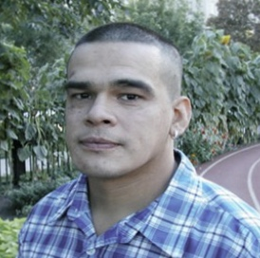

1) For what crime was Rolando Cruz sent to death row in Illinois?

2) How long was Cruz on death row?

3) After Cruz was arrested, why was the lead investigator in the case told to stop investigating the

crime?

4) Why did Rolando Cruz and Alex Hernandez say they contacted police and told them they had

information about the murder?

5) Why does author and attorney Scott Turow argue the police felt pressure to find a suspect on

which to pin the murder?

6) What “highly incriminating” piece of evidence was used to convict Rolando Cruz?

7) What was so controversial about the so-called “dream statement” Cruz supposedly made?

8) Who actually committed the rape and murder for which Cruz was convicted?

9) Why did the prosecutors who put Cruz in jail resist the new information that indicated someone else

had committed the crime?

10) Besides the fact he confessed, how can we be certain Brian Dugan was the real killer?

11) Why did the prosecution’s case against Rolando Cruz collapse during his retrial?

12) What happened to the police & prosecutors who built the phony case against Rolando Cruz?

13) What crimes did Brian Dugan go on to commit after the one that was falsely pinned on Rolando

Cruz and his buddies?

**AFTER VIEWING: Here’s the dilemma: If we abolish the death penalty, then serial killers like Brian Dugan won’t be executed. But if we don’t, innocent people like Rolando Cruz might be. Discuss where you stand on the death penalty. In what circumstances (if any) should we execute people in this country? Provide a thoughtful explanation for your opinion.**